   | 2016 - 2017 Updated 29.7.2017  RE, PSHE & SMSC DEVELOPMENT
 | Rationale | ECM Agenda | ECM 4: Every child has the right to overcome socio-economic disadvantages to achieve his/her full potential in life.  ECM 5: Every child has the right to contribute to the wider community & not to engage in anti-social or offending behaviour.
 | Rationale | Healthy Schools  Criteria 4 | The school has explicit values underpinning positive emotional health which are reflected in practice & work to combat stigma & discrimination
 | Rationale | PSHE curriculum | 1e. To find out about the range of jobs carried out by people they know & to understand how they can develop skills to make their contribution in society  5e. To meet & talk with people who contribute to society through environmental pressure groups or international aid organisations, people who work in our school & neighbourhood, such as religious leaders, community police officers
 | S | Spiritual | To nurture a sense of enjoyment and fascination in learning about themselves, others and the world around them
 | M | Moral | To nurture an interest in investigating and offering reasoned views about moral and ethical issues, and being able to understand and appreciate the viewpoints of others on these issues
 | S | Social | To nurture a willingness to participate in a variety of communities and social settings, including by volunteering, cooperating well with others and being able to resolve conflicts effectively
 | C | Cultural | To nurture an interest in exploring, improving understanding of and showing respect for different faiths and cultural diversity, and the extent to which they understand, accept, respect and celebrate diversity, as shown by their tolerance and attitudes towards different religious, ethnic and socio-economic groups in the local, national and global communities.
 |  | British Values | To develop an acceptance and engagement with the fundamental British values of democracy, the rule of law, individual liberty and mutual respect and tolerance of those with different faiths and beliefs;  To develop their ability to demonstrate skills and attitudes that will allow them to participate fully in and contribute positively to life in modern Britain.
 | Aims | - To enable pupils to apply oracy, literacy, numeracy & ICT skills in real world contexts  - To help pupils to understand the opportunities available to them, develop aspirations & understand how to achieve them  - To develop pupils’ wider skills & personal qualities such as working in teams, solving problems, organising activities & taking leadership roles.  - To create opportunities for pupils to develop enterprise capabilities, including their approach to innovation, creativity, risk-management & risk-taking, together with a positive attitude & the drive to make ideas happen  - To support pupils in developing an understanding of managing money, economics & business appropriate to their age (for example, why there are different jobs, how they might decide what the ‘best buy’ is & notions of fair trade)  - To support parents, carers & families in preparing pupils for their future education, training & employment

2016 – 2017 SMSC Focus |  |  | WHO DO WE THINK WE ARE
AUTUMN 2016 |  |  | SPRING 2017 |  |  |  |  |  | SUMMER 2017
Using role models & heroes to inspire us |  |  | Having a sense of our own identity |  |  |  |  |  | “More in common than divides us”
September | 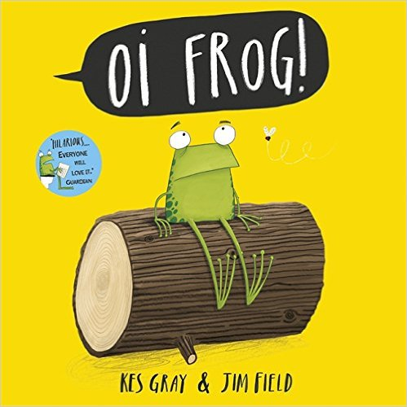 | Oi Frog  A story about how animals (and humans) are more than stereotypes and that each of us can be many people in one body | January |  |  | Being British & Cornish ppt  We are all part of many “families”  What things never change no matter where we live in Great Britain - British Values |  |  | April | Our post-Easter mission 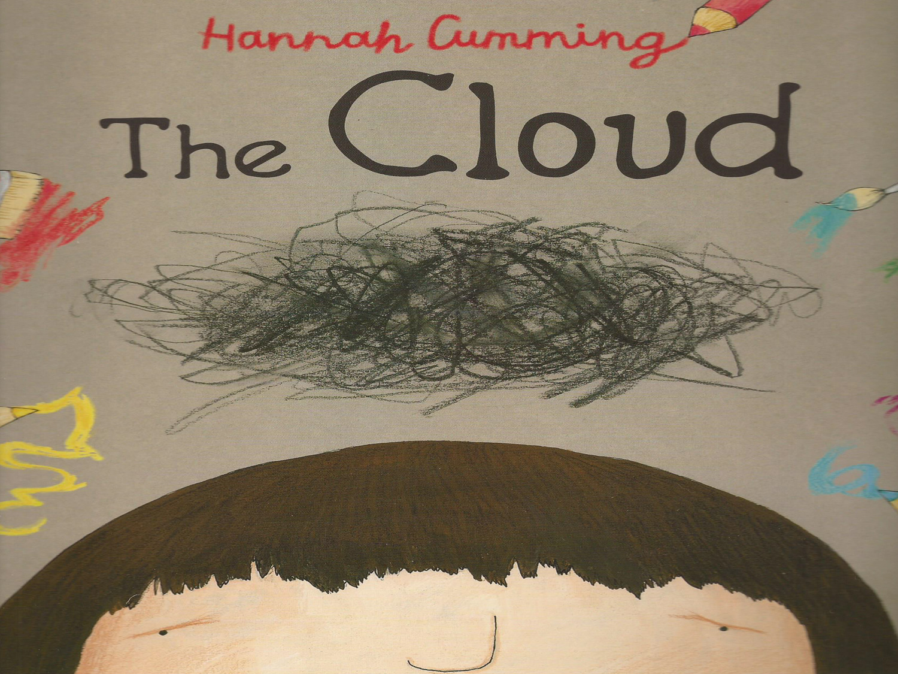 |  | How can we live a new or better life? Jesus was brave enough to die in public. Are we brave enough to live well in public? Are we brave enough to chase away any “clouds”? Let’s start in our school
OCTOBER | 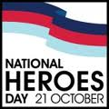 | Using National Heroes Day to explore either our own sense of Britishness and/or how we feel we belong within British society. We are using known and unknown British heroes to generate discussion and learning about who we think we are and what we might want to be in the future. | February | Chinese New Year – Year of the Rooster  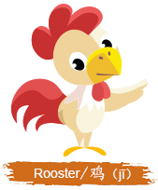 |  | Same, Same But Different ppt  Exploring the similarities & differences between the 14 days of the Chinese New Year & the 12 days of Christmas |  |  | May | 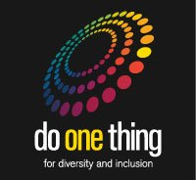 Do one thing for diversity |  | Global focus: UNESCO declared 21 May as UN World Day for Cultural Diversity. It is a chance for us to celebrate the cultural diversity of people around us, and find out more about what we have in common, rather than what separates us.
OCTOBER | The children used their hosen class hero (see below) as well as coming dressed as their personal national heroes to open their minds and hearts to the wealth of diversity surrounding us in terms of gender, race, religion, culture and (dis)ability etc. |  | March | 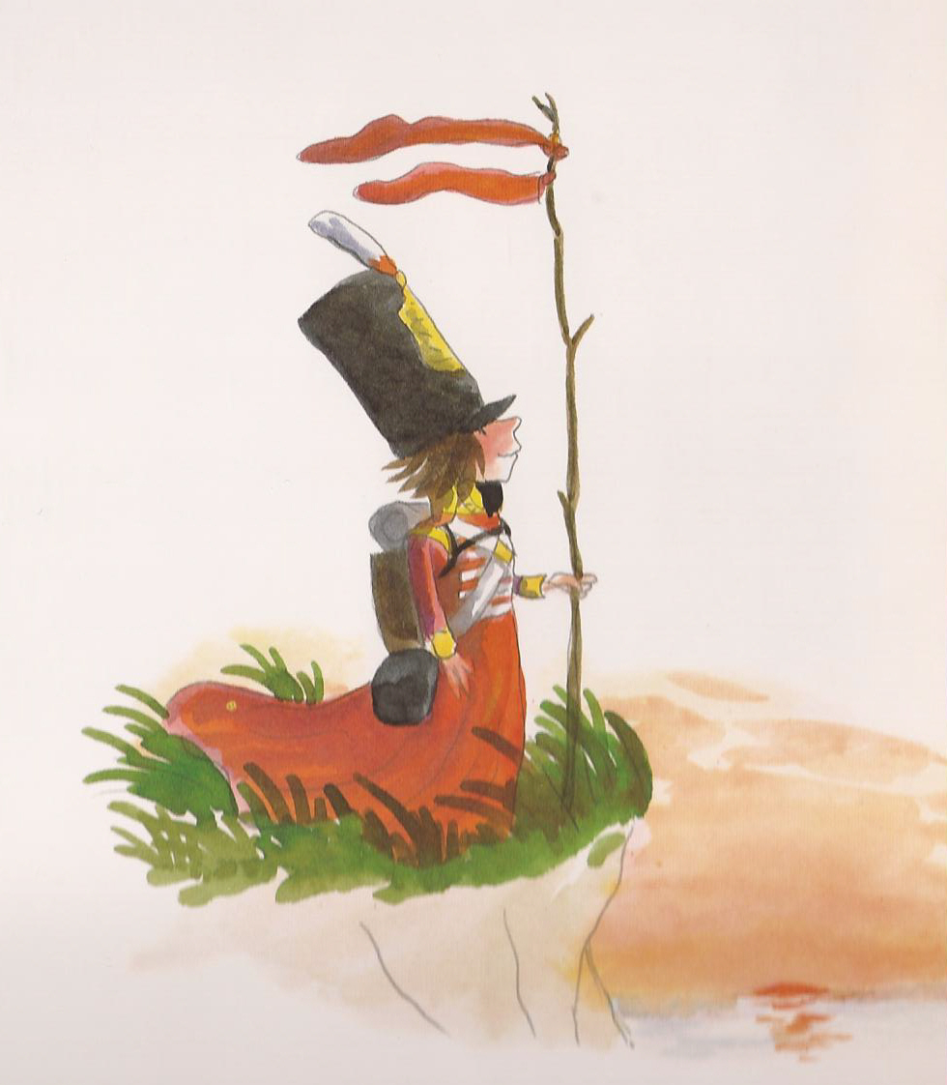 |  | St Piran’s Day: Seeing Red – a tale of how the women in a Cornish village tricked Napoleon Bonaparte & saved the day! |  |  | June | On Friday, June 23, we had a special Cultural Diversity assembly in school. Each year group shared with the rest of the school what they had explored and celebrated as part of their “Do One Thing for Diversity (see below) as well as their “What We Love About The World!” hall display
OCTOBER | Year R | Mums & Dads | March | Cornish enrichment day – celebrating all that it means to be Cornish or living in Cornwall |  |  |  |  | June
 |  |  |  |  |  |  |  |  |  | Year R | Volunteering at Care Home
OCTOBER | Year 1 | Richard Trevithick | March | Dance: contemporary Cornish dancing with House Team dance-off |  |  | Music: Sharing in a rendition of new & familiar Cornish songs |  | June | Year 1 | Cooking around the world
OCTOBER | Year 2 |  |  |  |  |  |  |  |  | Year 2 | Bollywood dancing
OCTOBER | Year 3 | Sir David Attenborough |  |  |  |  |  |  |  | Year 3 | Islamic art
OCTOBER | Year 4 | Horatio Nelson | March | Humanities: “Pin the Place” on the Cornish Map |  |  | Food: Tasting and sampling of Cornish sweet treats |  | June | Year 4 | Capoeira
OCTOBER | Year 5 | Shackleton |  |  |  |  |  |  |  | Year 5 | Mayan civilisation
OCTOBER | Year 6 | 2016 Paralympic athletes |  |  |  |  |  |  |  | Year 6 | Hinduism
NOVEMBER | 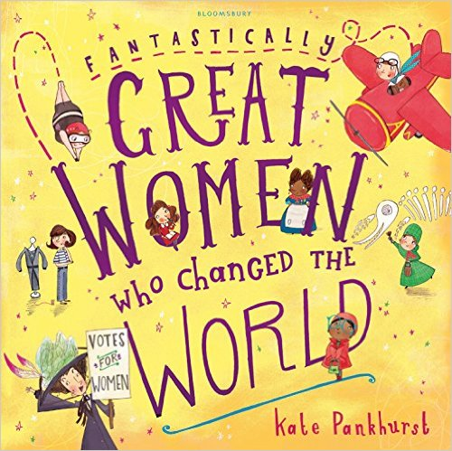 | Great Women Who Have Changed The World - the perfect introduction to just a few of the most incredible women who helped shaped the world we live in. |  | House Teams competition - to design a shield for each of our 4 houses celebrating what makes each house unique & special. The winning design will be painted onto a shield & will be displayed in the foyer of the school for everyone to admire. |  |  |  |  | June | 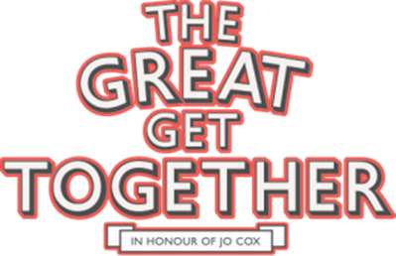 |  |  | We decided, as a school, to join in with millions of people across the country for the biggest community celebrations since the Jubilee, and powerfully show we have more in common.
NOVEMBER | 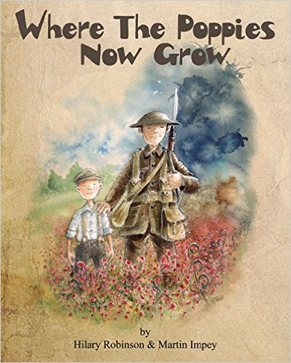 | Where The Poppies Now Grow - using the story of 2 friends who served their country in WW1 to remind us to value freedom & democracy in Britain today |  | Beckett | Grindall |  | Islip | Benson |  | Having looked at diversity in school as part of our celebration of the UN Cultural Diversity Day (May 21), we decided to link the theme of diversity and inclusion into our Summer Eucharist Service. The date for the service tied in with The Great Get Together event, in memory of Jo Cox, MP.

Possible Fundraising & Voluntary Work
Local charity: |  |  | National charity: |  |  | International charity:
 |  |  | 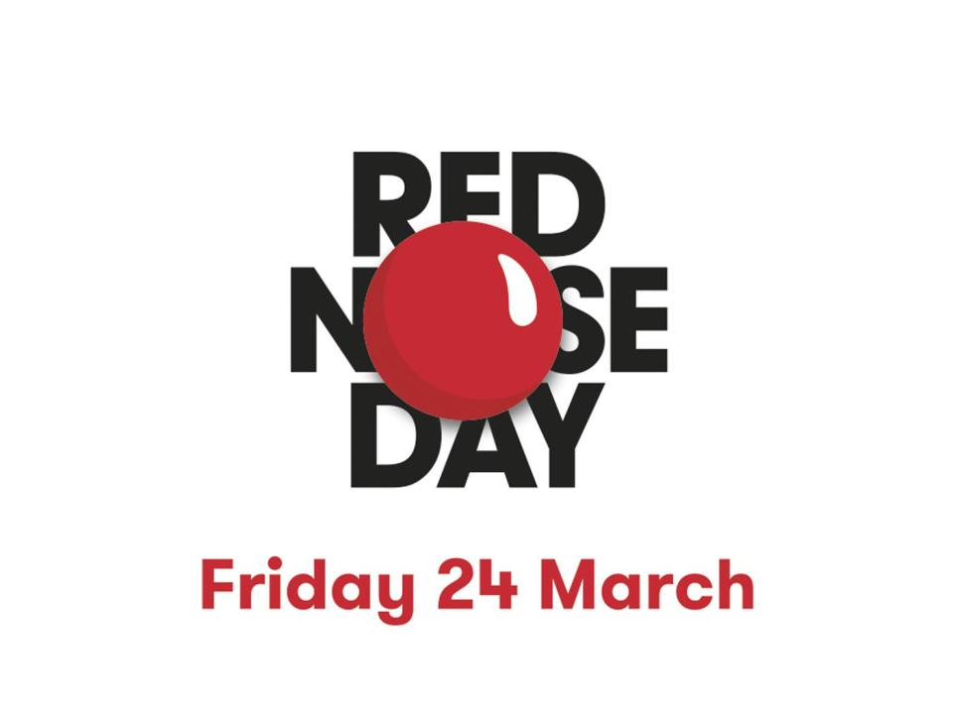 |  |  | 
Moral development: An ability to recognise the difference between right and wrong and to readily apply this understanding in their own lives
AUTUMN 2016 FUND-RAISING |  |  | SPRING 2017 FUND-RAISING |  | SUMMER 2017 FUND-RAISING
Harvest Collection:  Donations to Truro Food Bank |  |  | Comic Relief  Have A Laugh – joke telling competition  £179.30 |  | Cornwall Air Ambulance  Wear What You Want Day  £435
Year R | Smash
Year 1 | Tinned potatoes
Year 2 | Long life juice
Year 3 | Coffee
Year 4 | Biscuits
Year 5 | Rices & custards
Year 6 | Pasta sauces
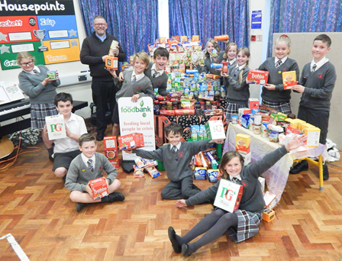 |  |  | 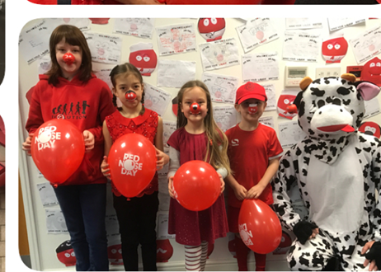 |  | 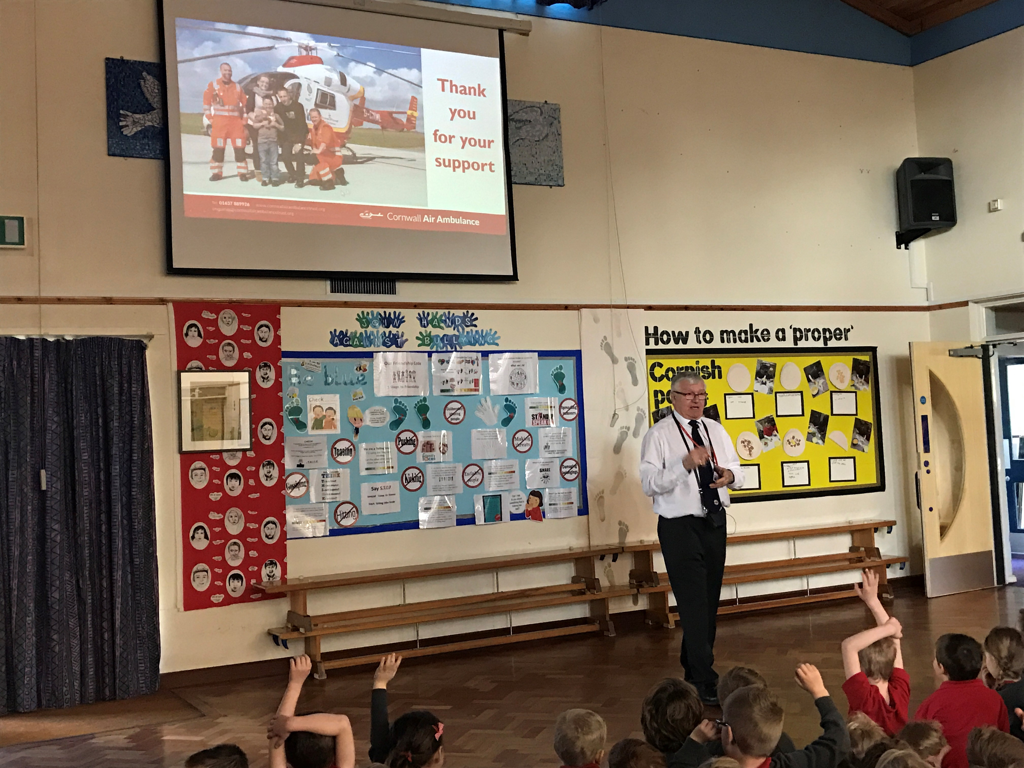
Children In Need
Coin collection & sculpture
£406.81
Children’s Society
Christmas service collections
£338.72
AUTUMN 2016 VOLUNTARY WORK |  |  | SPRING 2017 VOLUNTARY WORK |  | SUMMER 2017 VOLUNTARY WORK
Social Development: A willingness to participate in a variety of communities and social settings, including by volunteering,

